Parent Portal Directions

- Go to the Walton website and click on “Parents”.

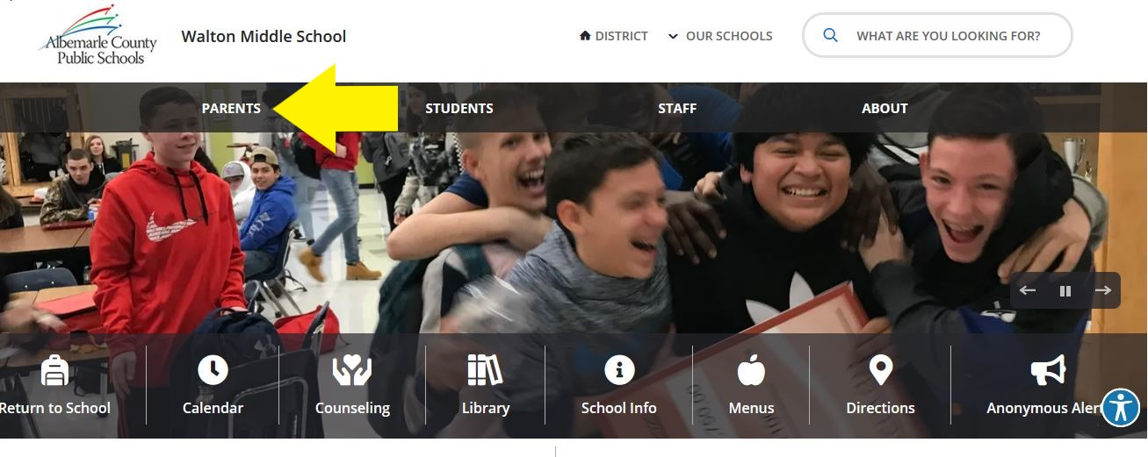

- On the right side of the page, click on ParentPortal.

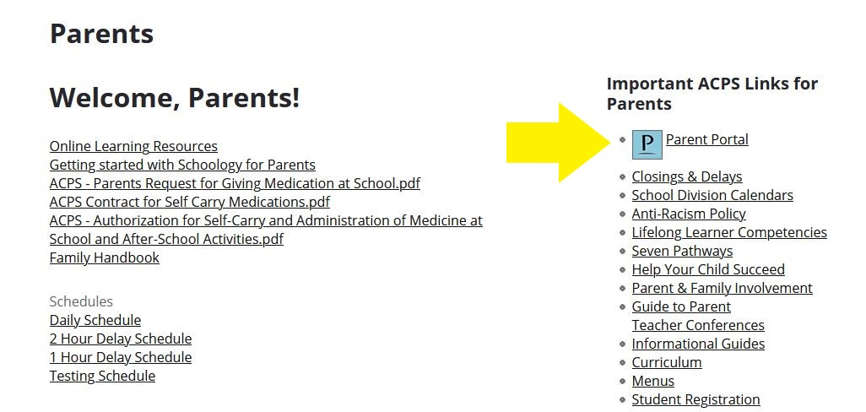

- Enter your information to log in. If you do not have Parent Portal access, please contact Karen Collier at Walton at 434-977-6533.

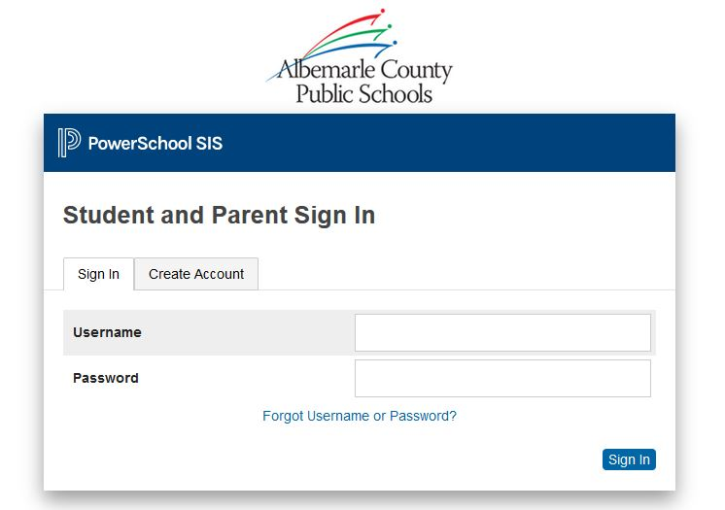

- Click on Course Registration on the left hand side.

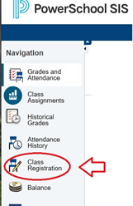

- Click on the pencils on the right side to select courses. Courses like Science, History, and Health/PE will be assigned to you by WMS.

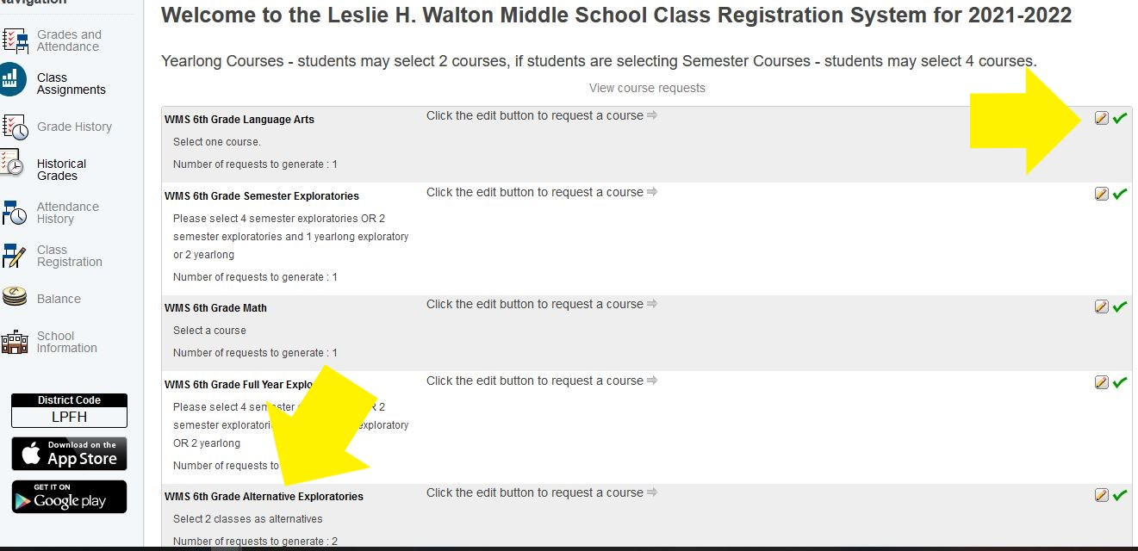

- Note that the alternate exploratories are backup options in case your child’s first choices are not available (shown above).

- When you are finished, click the Submit button on the bottom right side.

