January 21, 2021

Dear Parent/Guardian,

We are excited to begin the process of scheduling your child’s 8th grade classes for the 2021-2022 school year! Within this packet you will find:

- The transition timeline.
- Course descriptions and associated course numbers.
- Instructions for selecting courses in ParentPortal.

Our course registration process changed last year to align with the ACPS Anti-racism policy. Essentially, students/parents will make course selections before teachers respond to student course requests with teacher recommendations and uniform comments in the Portal. To read more about the policy and the changes to course registration, you can visit: http://esb.k12albemarle.org/Reference_Library/ESB_Policies_and_Regulations/Policies//ACC.pdf

Using the information provided on the next few pages, we encourage you to speak with your child to select courses that provide the appropriate level of challenge. The final page of this packet includes the online steps to select your child’s courses. If you have questions, you can speak with your child’s teacher, counselor, or case manager.

Transition Timeline

- January 18 - February 12: Parent Portal opens for students and families to sign up for courses.
- February 1-4: Counselors visit 6th and 7th grade language arts classes to help students select classes.
- February 12: Parent Portal is open for parents/guardians to view only. Starting on this date, any course request changes will be completed by the student’s counselor.
- February 15-19: Teachers verify course level selections and make notes in PowerSchool to align requests.
- February 22 - March 5: Students and families may work with teachers and counselors to understand any discrepancies in course selections and teacher comments.
- March 8: ConnectEd sent and letter with course requests mailed home.

Please feel free to contact the counseling office at 434-977-6533 if you have questions, or contact your child’s counselor by email using the addresses listed below.

Sincerely,

Doug Bloor Makenzie Crawford
School Counselor School Counselor
Serving current 8th graders and Serving current 6th graders and
7th graders with last names A-L 7th graders with last names M-Z
8th Grade Math and Language Arts Course Options
*Please take note of the course number when selecting courses as the course names will all look similar. AD designates an advanced course and HO designates an honors course.
 | 8th Grade Course | Course Number | Course Information
Language Arts | Lang Arts 8 | M01036 | Students in this section benefit from small group or scaffolded reading instruction. Writing assignments are chunked in order to better understand the writing process. (SOL scores 420 or below)
 | Lang Arts 8 Advanced/ Honors | M01036AD | Students in this section are proficient readers and writers. They have met all benchmarks for grade level performance in language arts. (SOL scores 421-470)
 | Lang Arts 8 Adv/Hon Alternate | M01036AL | Students in this section are preparing for Advanced Placement (AP) style writing. They are ready to take on complex texts independently. Typically, this student is well organized, creative, and enjoys language arts. This course is held every other day opposite of a French I or Spanish I, which are high school credit courses. (SOL scores 471 or higher)
Math | Math 8 | M02038 | Students who take this course will prepare to take Algebra I in 9th grade by investigating pre-Algebra concepts.
 | Algebra I  (high school credit course) | 02052HO | Students who take Algebra I in 8th grade for a high school credit were successful in Math 7 or successfully completed the Algebra Bridge Summer Camp. These students generally have a Math MAP score of 235+ and a score of 450+ on the Math 7 SOL.
 | Geometry  (high school credit course) | 02072HO | Students who take Geometry for a high school credit in 8th grade must have passed the Algebra I course as well as the Algebra I SOL.

2021/2022 8th Grade Exploratory Options

Please use one of the following to select your 7th grade course options. You will choose your classes based on one of the following options:
- 2 yearlong courses
- 1 yearlong course and 2 semester courses
- 4 semester courses

YEAR-LONG ELECTIVES

_____ AVID: Advancement Via Individual Determination 8 (application or prior enrollment)
AVID is a class for students who would like extra support in fulfilling a dream of going to college. It focuses on writing, inquiry, reading, and collaboration to prepare students for the required course load in high school. This elective can be continued at MHS.

_____ Band 8 (prior enrollment, full block)
Students who play band instruments receive sequential instruction on their instrument. They typically perform several formal concerts during the year and may participate in competitive district events, festivals, and parades. Selected advanced students may also participate in the county's Honors Band Program.

_____ Chorus 8
Students practice and perform choral literature drawn from a variety of musical styles and foreign languages, including Latin. They may participate in festivals and district events beyond the school. Selected advanced students may also participate in the county's Honors Chorus Program.

_____ Strings 8 (prior enrollment)
Students who play stringed instruments receive sequential instruction. They typically perform several formal concerts during the year. Advanced students may have the opportunity to participate in district strings events.

_____ CTE Manufacturing Exploration 8
A Career and Technical Education (CTE) course that students will learn how to modify and control the world around them through exploring, designing, analyzing and evaluating the systems of design, programming, and electronics. Students will learn programming and electronics through the use of microcontrollers. Students will use computer-aided design software and advanced manufacturing technologies (3D printing, die-cutting, CNC machining, etc.) to create physical objects. The three systems of computer programming, electronics and design will be combined to create mechanical-electrical devices that are computer-controlled. Students will also explore technology-oriented careers

_____ Spanish I OR _____ French I (full block, HS credit class)
Eighth grade students have an opportunity to take French I or Spanish I. Coursework includes a strong emphasis on speaking, listening, reading, writing, and cultural awareness. Basic vocabulary and essential grammar are taught. Students who complete this first-year high school program successfully may elect to earn high school credit for the course and take French II or Spanish II in ninth grade.

SEMESTER ELECTIVES

_____ Art 8
Eighth grade students use the principles of design as the basis for a study of line, color, and texture. They create clay sculptures using slab construction, draw human figures, use multiple perspectives, make prints, and create and maintain a portfolio of their work. Eighth graders also examine the art and architecture of different times and cultures and learn to critique their own work and the work of others.

_____ Drama 8
Drama students develop a variety of improvisational and more formal acting skills. Students learn fundamentals of stage design and presence, performing selected dramatic works as a troupe. Emphasis is placed on gaining comfort in a variety of performance styles while building confidence in public communication skills.

_____ CTE STEM Engineering Exploration 8
Students will explore the engineering design process and real-world problem solving through the use of technologies including computer-aided design software, electronics, 3D-printing and CNC machining to discover their related applications. Students make models of significant inventions that have advanced society. After studying these developments, they explore contemporary technological problems facing them, their community, or the world and apply systematic procedures to invent new products or innovations as solutions.

_____ CTE Programming: Media and Gaming 8
Students will use a variety of platforms to code computer programs and/or create multimedia projects that impact and interest them. Students will learn to evaluate their work and others' as part of the self-improvement process.

_____ CTE Business and Entrepreneurship 8
Students will learn concepts and techniques for planning an innovative business and living the entrepreneurial lifestyle. Students will study effective leadership principles and innovative problem-solving skills.

_____ Yearbook 8
Help develop the school's yearbook. Students will participate in the full development of the yearbook which includes: photography, superlative awards, and various school news items.

In addition to these courses above, please select 2 classes to be your alternate or back-up courses in case your initial requests cannot be fulfilled.
1:______________________________
2:______________________________
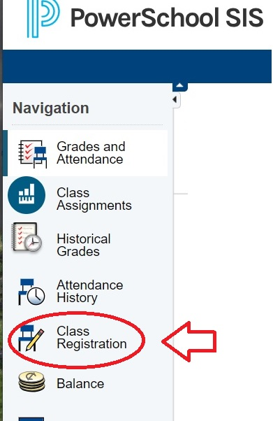
To Register on ParentPortal, sign in as normal. On the left, look for “Class Registration”

Beside each subject, click the pencil icon for courses available.
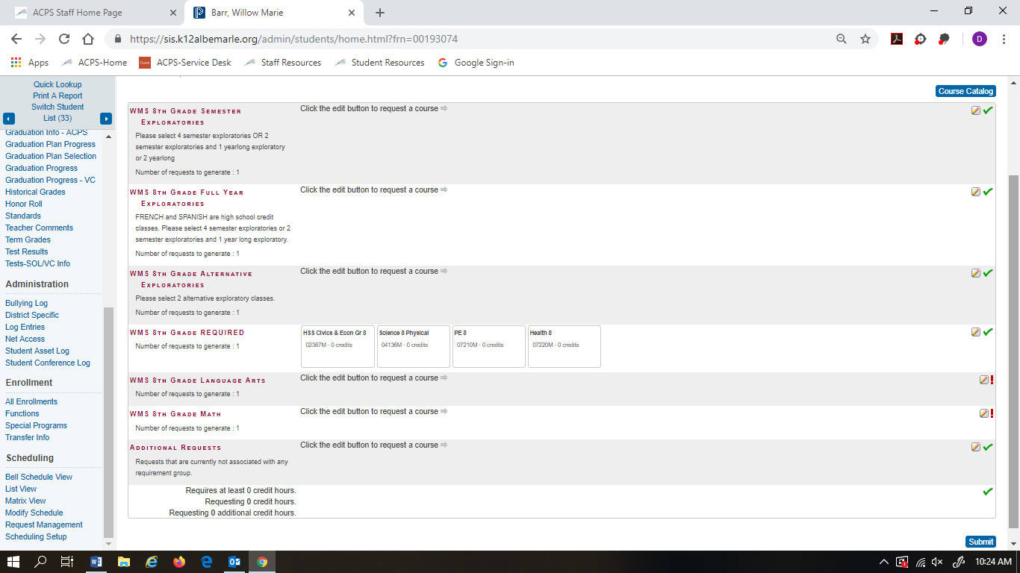

Please follow instructions listed under each subject area. Please note that History, Science, Health, PE, and Advisory are automatically loaded. When finished, make sure to hit the “Submit” button in the bottom right corner.
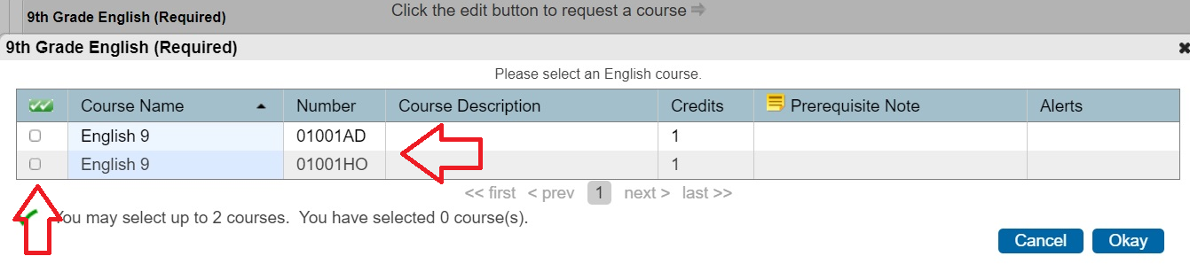
Select the course you want to take by checking the box. Courses with “AD” at the end are Advanced. Courses with “HO” at the end are Honors.

